**Implications of the (changing) relationship between life expectancy and lifespan inequality**

José Manuel Aburto, Ginevra Floridi and Ella Fegitz

**Abstract**: Life expectancy at birth is widely employed to measure longevity. However, as José Manuel Aburto, Ginevra Floridi and Ella Fegitz argue, another dimension is of great relevance in health research and policy intervention is inequality in the length of life.

**BIO**

José Manuel Aburto. Department of Sociology & Leverhulme Centre for Demographic Science, University of Oxford, UK; and Interdisciplinary Centre on Population Dynamics, University of Southern Denmark.

Ginevra Floridi. Department of Global Health & Social Medicine, King’s College London, UK.

Ella Fegitz. Department for the Study of Culture & Interdisciplinary Centre on Population Dynamics, University of Southern Denmark.

**What are life expectancy and lifespan inequality?**

Life expectancy at birth is a measure of the mean level of mortality. Simply put, it expresses the average number of years a newborn is expected to live given the mortality conditions at a point in time. Because it is an average, life expectancy does not show differences in length of life among people; however, these can be substantial. To fully understand mortality at the population level, life expectancy can be complemented by *lifespan inequality*, which measures variation in ages at death, capturing differences in lifespans. Lifespan inequality has been described as the most fundamental of all inequalities, because every other type of inequality is conditional upon being alive (van Raalte, Sasson, & Martikainen, 2018). Its level and evolution can tell us much about how equitably health improvements are allocated in a society.

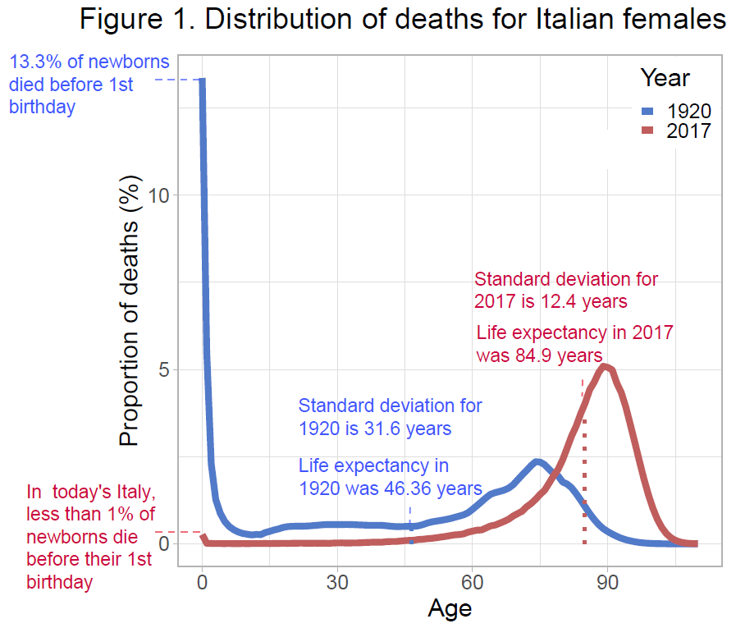At the individual level, lifespan inequality tells us how unpredictable the timing of death is. For example, using the standard deviation of ages at death (SD) as a measure of lifespan inequality, predicting how long a newborn in Italy would live was considerably more difficult in 1920 (SD = 31.6 years) than it was in 2017 (SD = 12.4 years) because, in 1920, deaths were more spread over age (Figure 1).

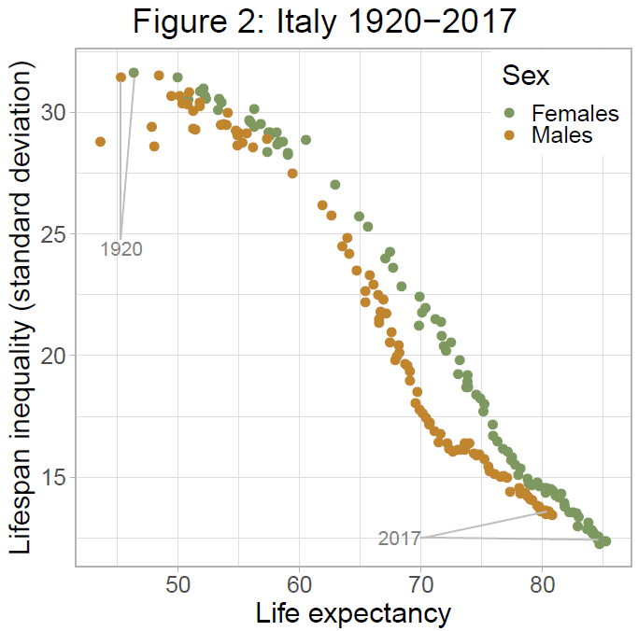**How does life expectancy relate with lifespan inequality?**

In 1920, 13.3% of females born in Italy died before their first birthday and less than 10% of them were expected to reach the age of 82. In contrast, 99.7% of female babies born in 2017 survived to their first birthday and almost 70% of them are expected to be alive in 2100 (Figure 1). This exceptional progress in reducing mortality has meant that life expectancy at birth increased from 46.4 years to almost 85 years over the last century and, at the same time, that life chances have become more equitable, i.e. that lifespan inequality has decreased (Figure 2).

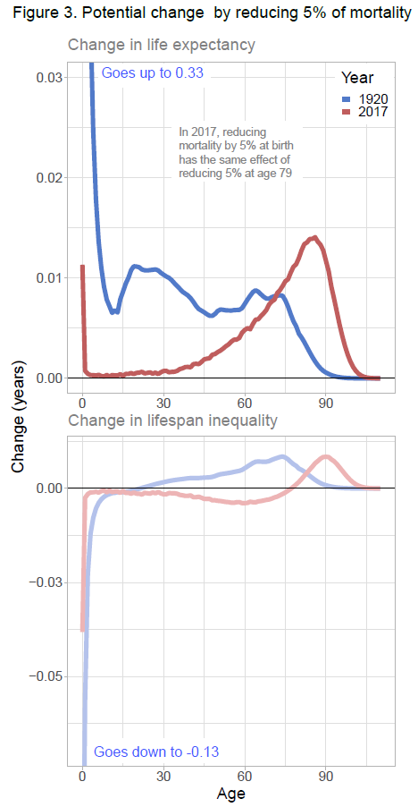Higher levels of life expectancy usually correspond to lower levels of lifespan inequality (e.g. Smits and Monden 2009). However, historically, this has not always been the case. In certain countries, during specific periods, lifespan inequality has been shown to stall or even increase despite improvements in life expectancy, or vice versa. In Venezuela from 1996 to 2013, life expectancy increased (69.4 to 71 years) together with lifespan inequality (SD from 20.7 to 21.7 years). This resulted from progress made at almost all ages, including infant mortality, being offset by increases in violent deaths concentrated among young males (García & Aburto, 2019).

A recent article shows that changes in both life expectancy and lifespan inequality can be expressed as rates of progress in reducing mortality (Aburto et al 2020). Increases in life expectancy will only correspond to decreases in lifespan inequality if mortality reductions are concentrated at younger ages (usually below life expectancy). However, in contemporary societies, increases in life expectancy are often attributable to improvements in old-age mortality.

For example, in 1920’s Italy, the biggest gains in life expectancy were achieved if progress was concentrated at infancy. By contrast, in today’s Italy, reducing infant death rates by 5% leads to the same gain in life expectancy as reducing mortality at age 79 by 5% (Figure 3). This has potential implications for the relationship between life expectancy and lifespan inequality. Saving lives at infancy increases life expectancy and reduces lifespan inequality; however, if progress is concentrated at ages above 79, life expectancy and lifespan inequality will both increase (Figure 3).

**Societal implications of increased lifespan inequality**

Lifespan inequality is important because, in making important life decisions, people are influenced by the mortality experience of those around them. Subjective beliefs about one’s lifespan has been shown to affect decisions such as whether and when to invest in education, save, buy a house, or retire (e.g. Bloom et al., 2006).

A potential weakening or reversal of the negative relationship between lifespan inequality and life expectancy means that, while people live longer on average, individuals also face greater uncertainty around when they will die. Studies have shown that, within a society, such increased uncertainty is likely to be concentrated among those from disadvantaged socio-economic groups. For example in Finland, between 1971 and 2014, subgroups with low educational attainment and low incomes experienced increasing lifespan inequality, while more advantaged groups experienced reduced lifespan inequality (van Raalte et al., 2018). This represents a “double burden” for lower socio-economic groups experiencing not only shorter lifespans, but also higher uncertainty around them compared to the more advantaged groups.

Diverging patterns in lifespan inequality across socioeconomic groups may have important consequences for the perpetuation of social inequalities. For instance, faced with greater uncertainty about their own lifespan, individuals from disadvantaged socio-economic backgrounds risk making unfavorable financial decisions and this could further reduce their financial resources later in life. Lifespan inequality is also likely to create uncertainty about the timing of inheritances and financial bequests among family members. If this uncertainty is concentrated among lower socio-economic groups, poorer individuals may not only receive smaller transfers from their parents and grandparents than the rich; they may also be less able to plan around the timing of those transfers. Given the importance of these transfers for the recipients’ socio-economic conditions, higher lifespan inequality may strengthen the transmission of disadvantage across generations, reducing intergenerational social mobility.

**The significance of including lifespan inequality in policy and research**

Increasing the average age at death alone is not enough for guaranteeing a more equitable distribution of the length of life. An important message of recent research is that policies and interventions can affect this relationship by reducing mortality at the ages that matter the most (Aburto et al., 2020). In terms of policy interventions, one important question to ask is how different types of healthcare investments, such as preventive as opposed to end-of-life care, may relate to inequality in lifespans. Another important question is how the strength of the relationship between life expectancy and lifespan inequality varies across societies and periods characterized by different levels of social inequality. There is reason to believe that more equal or socially cohesive societies may be more effective at reducing lifespan inequality, for example through reductions in violent crimes or greater access to preventive healthcare across all socio-economic groups. These are promising avenues for future research linking demographic phenomena to the broader societal context in which they take place, with important implications for social policy.

**References**

[Aburto, J. M., Villavicencio, F., Basellini, U., Kjærgaard, S., & Vaupel, J. W. (2020). Dynamics of life expectancy and life span equality. *Proceedings of the National Academy of Sciences*.](https://doi.org/10.1073/pnas.1915884117)

Bloom, D. E., Canning, D., Moore, M., & Song, Y. (2006). The effect of subjective survival probabilities on retirement and wealth in the United States. *NBER Working Paper, 12688*.

García, J., & Aburto, J. M. (2019). The impact of violence on Venezuelan life expectancy and lifespan inequality. *International journal of epidemiology*.

Smits, J., & Monden, C. (2009). Length of life inequality around the globe. *Social Science & Medicine, 68*(6), 1114-1123.

van Raalte, A. A., Sasson, I., & Martikainen, P. (2018). The case for monitoring life-span inequality. *Science, 362*(6418), 1002-1004.